Create a simple script file and push it to repo. Create a project in Jenkins connected to your GitHub repository. When a commit is made to your repo, automatically build must get triggered from Jenkins and the output must be shared to me via email.

Git- Setting up a Repository

Git is a popular version control system that helps track code changes and manage collaboration. Setting up a Git repository is the first step to effectively use its features.

Manages and tracks changes in a codebase.

Supports both personal and team projects.

Repository setup includes installation, initialization, and configuration.

Benefits of Using Git

Version Control: Track changes over time and revert to previous states if needed.

Collaboration: Work with others seamlessly by merging changes and resolving conflicts.

Backup: Keep your code safe by pushing it to remote repositories like GitHub, GitLab, or Bitbucket.

Branching: Experiment with new features without affecting the main codebase.

Steps to Setting up a Repository

Step 1: Install Git

Windows

Run the installer and follow the setup instructions. Use the recommended settings unless you have specific preferences.

Download git for windows

macOS

/bin/bash -c "$(curl -fsSL https://raw.githubusercontent.com/Homebrew/install/HEAD/install.sh)"

Install Git using Homebrew:

brew install git

Linux

Install Git using the package manager for your distribution. For example, on Debian-based systems like Ubuntu:

sudo apt update
sudo apt install git

Verify the installation by running:
git --version

Step 2: Configure Git

Before using Git, it’s essential to configure your identity. This information will be included in your commits.

Set your username:

git config --global user.name "Your Name"

Set your email:

git config --global user.email "your.email@example.com"

You can check your configuration settings at any time using:

git config --list

Step 3: Initialize a New Repository

Creating a New Repository

Navigate to your project directory:

cd /path/to/your/project

Initialize the repository:

git init

This command creates a new .git directory in your project folder, marking it as a Git repository.

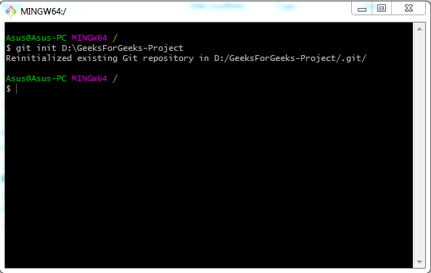

Adding Files to the Repository

Add files to the staging area:

git add .

This command stages all the files in your project directory for the initial commit. You can also add specific files by listing them individually.

Commit the files:

git commit -m "Initial commit"

This command commits the staged files to the repository with a message describing the commit.

Step 4: Working with a Remote Repository

To collaborate with others or keep a backup of your repository, you can use remote repositories hosted on platforms like GitHub, GitLab, or Bitbucket.

Creating a Repository on GitHub

Sign in to GitHub and navigate to GitHub.

Click on the "+" icon in the top right corner and select "New repository".

Fill in the repository details (name, description, etc.) and click "Create repository".

Connecting Your Local Repository to the Remote Repository

Add the remote repository URL:

git remote add origin https://github.com/yourusername/your-repository

- Push your local commits to the remote repository:

git push -u origin main

Step 5: Cloning an Existing Repository

If you want to start working on an existing project, you can clone a remote repository to your local machine.

Navigate to the desired directory where you want to clone the repository:

cd /path/to/directory

Clone the repository:

git clone https://github.com/username/repository

This command creates a copy of the remote repository on your local machine

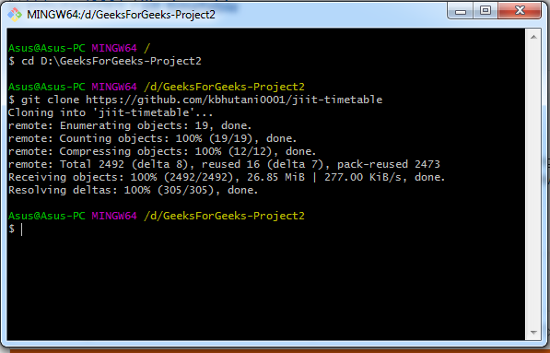

TO PUSH A PROJECT AND CONTRIBUTE ON GITHUB:

- INSTALL GIT

Follow the installation on operating system on windows, macos and then linux

2. Create a GitHub Account

Sign up for a free account at github.com.

Configure Git

Open your command line interface (CLI) or terminal.

Set your username and email with the following command.

git config --global user.name "Your Name"
git config --global user.email "your.email@example.com"

Pushing a Project to GitHub

Once you have Git and GitHub set up, you can push your project to a GitHub repository.

1. Create a New Repository on GitHub

Go to your GitHub account and click the + icon in the top-right corner.

Select New repository.

Enter a name for your repository and click Create repository.

2. Initialize a Local Repository

Navigate to your project directory in the CLI.

Initialize a Git repository:

git init

3. Add and Commit Your Files

Add all your project files to the staging area:

git add .

Commit the files with a meaningful message:

git commit -m "Initial commit"

4. Add the Remote Repository

Link your local repository to the remote repository on GitHub:

git remote add origin https://github.com/your-username/your-repository

5. Push the Project to GitHub

Push your committed changes to the remote repository:

git push -u origin main

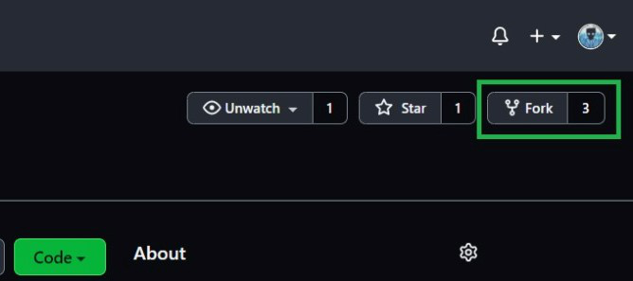

After that, we need to open the files of the forked repository on our local PC. For this, we can use Terminal or open Git Bash on that folder, which can be installed separately on our PC. Create a new folder, where we want to store the files from the repository, and then we need to run the following commands:

git init
git remote add origin "link to your forked repository"
git pull origin "branch name"

This will pull all the files from your forked repository to our local PC folder. Here, a typical "link to your forked repository" looks like this:

https://github.com/username/repo-name

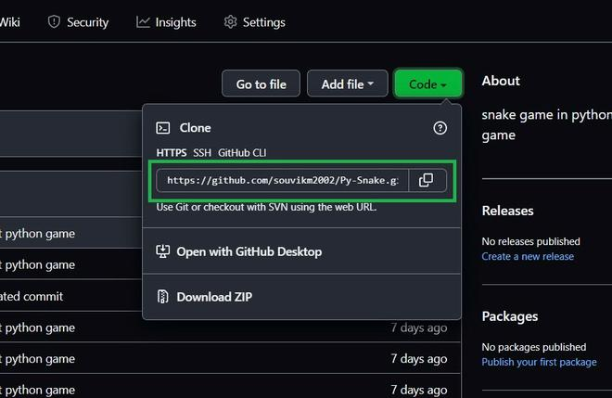

The command in the Git Bash will be:

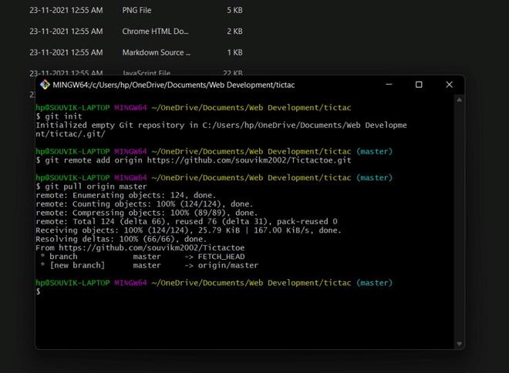

If the repository has more than one branch, then we can shift our branches by running the following command in our Git Bash terminal:

git checkout "branch name"

For checking the branch name we are currently in, we need to run this command:

git branch

For example, if we are in the dev branch and we want to shift to the master branch, then we will use this command:

git branch
git checkout master
git branch

The output of the following command will be like this:

* dev
master

This means you are working inside the dev branch.

dev
* master

This means you are working inside the master branch.

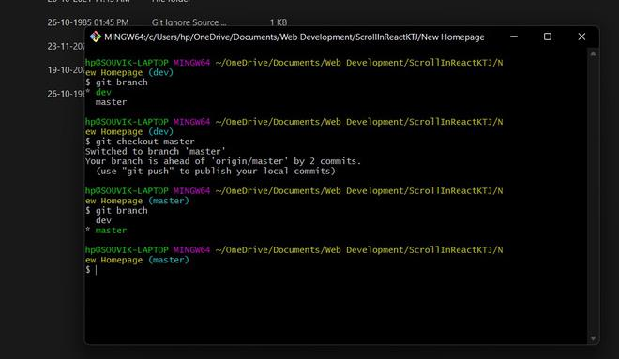

Save our changes to our forked repository

To add all the changes we made in our code to the local repository, we need to log in to our Github account in Git Bash and run the following command in Git Bash:

git add .
git commit -m "test commit"
git push -u origin "branch name"

If the branch name is master, then the last command would be:

git push -u origin master

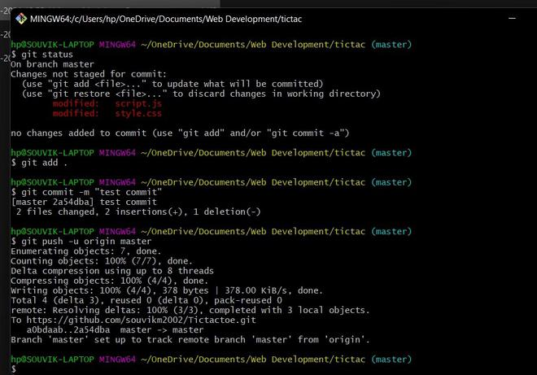

This successfully copies all the updated files to our forked repository. We can also add files selectively using the specific file name which we want to push in our forked repository. We can check the files which are updated by running the command:

git status

This shows all the files that are updated by the user which are yet not committed. If the file name is "upgraded.js", then the command will be:

git add upgraded.js
git commit -m "saving changes"
git push -u origin "branch name"

How to Create a Pull Request to the Original Repository?

Only after we made certain changes and upgradations in our forked repository, the option to Open pull request will be visible on clicking Contribute button that indicates that your forked repository has some commits/upgradations that are yet not added to the original repository.

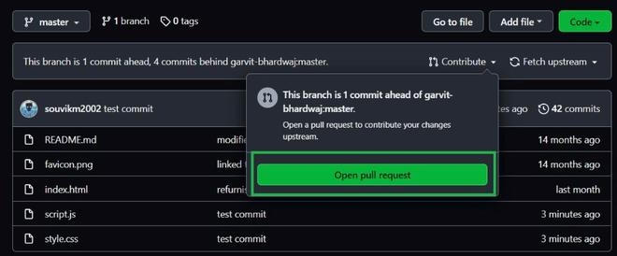

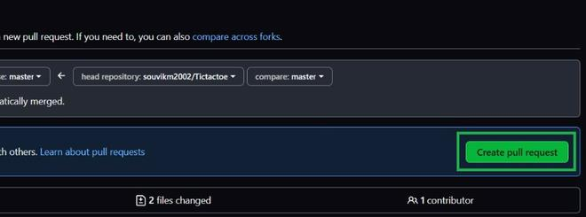

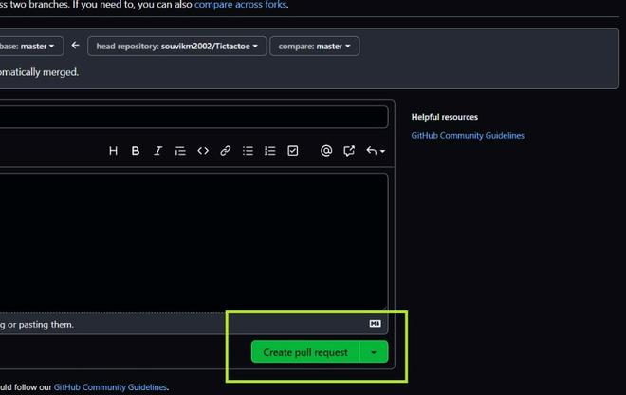

Click on the contribute button, and it will open a page that allows us to open a pull request and set the name of your pull request, and you can write some additional description about the changes made. After submitting the pull request, the request is sent to the maintainer/owner of the original repository, which may be accepted if the maintainer likes the changes/upgrades made by us.

How to Push Anything to GitHub using Git Bash?

GitHub has become the go-to platform for collaborative software development, offering powerful tools for version control, collaboration, and project management. Git Bash, a command-line interface for Git on Windows, provides a quick way to interact with GitHub repositories. In this guide, we'll learn about the process of pushing anything to GitHub using Git Bash.

Steps to Push on GitHub using Git Bash

Step 1: Make a GitHub repository by clicking on the “new“ Button.

Step 2: Now after clicking on that, you will see a screen something like as show below in the image.

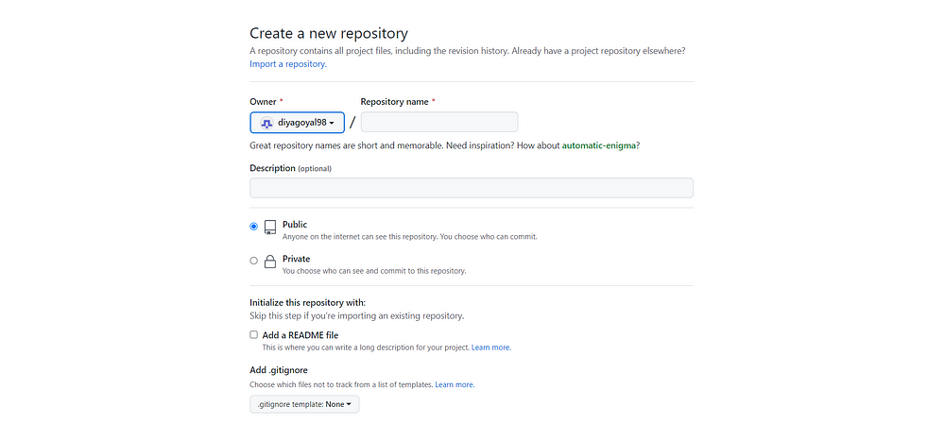

Step 3: Give the name of your repository and give a short description of your repository.

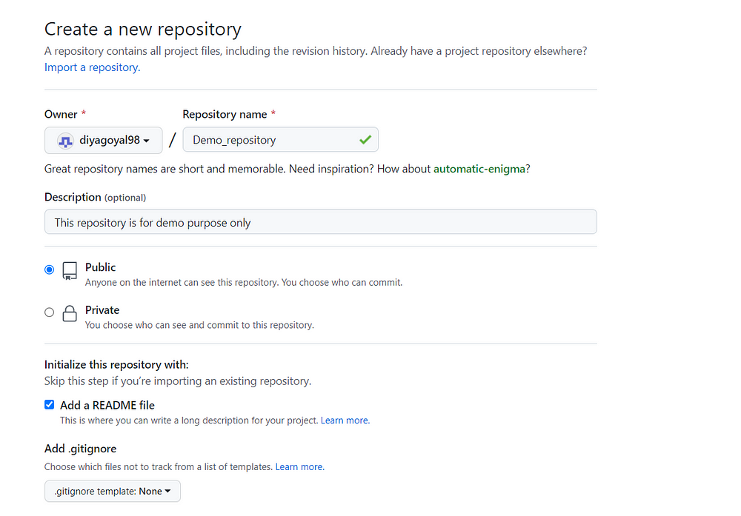

Step 4: After that just click on the “create repository “ option.

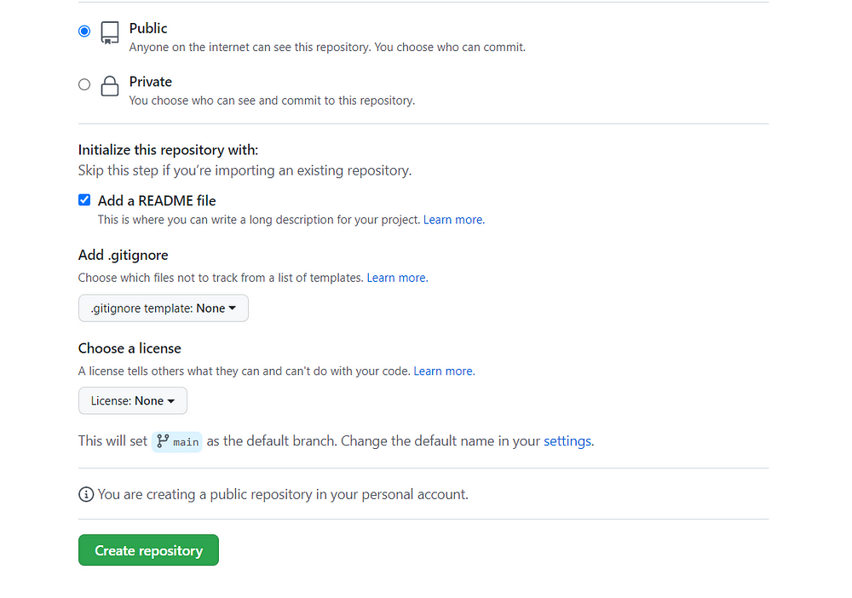

Step 5: After that, your repository has been created successfully.

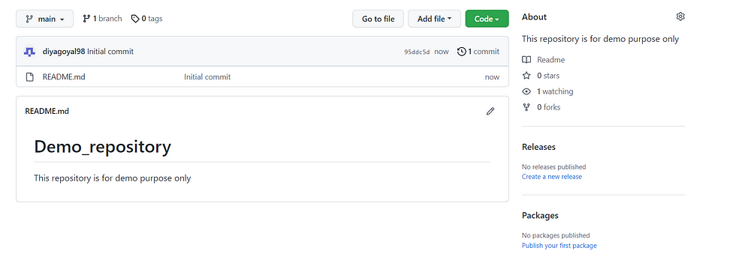

Step 6: Now go to the local folder that you want to push on GitHub and after a right click a menu will show in which you have to click on “Git bash here”.

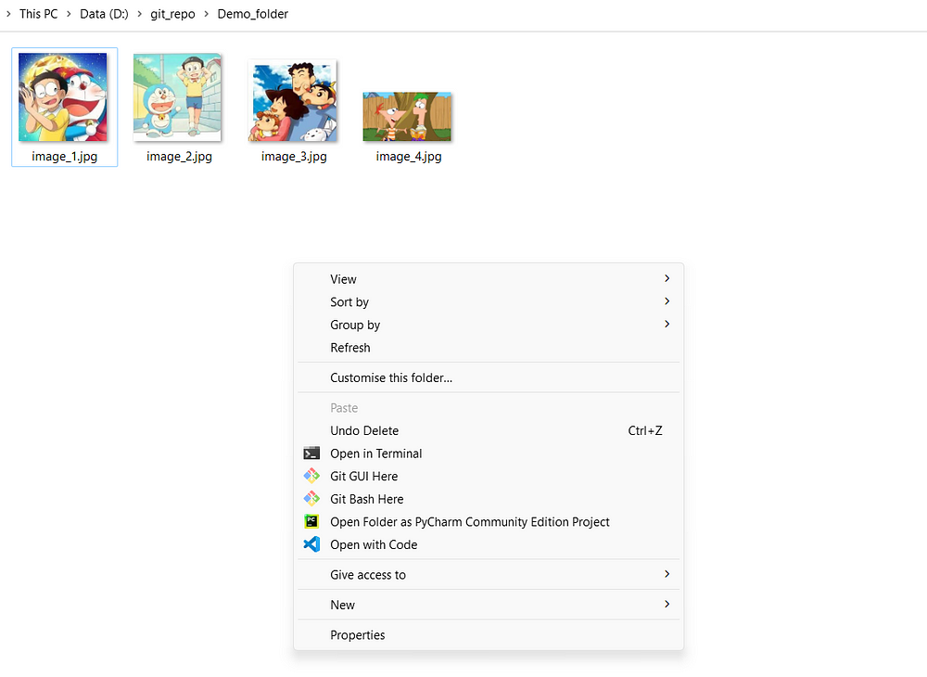

After that GitBash will open and now you have to make a clone of the repository that we have just made. We can make the clone by simply writing the command “git clone https://link”. This https link we will get from our repository.

How to get this https:// link??

Just go to your repository and there is an option name “Code” just click on that and how you are able to see the https:// link so just copy that.

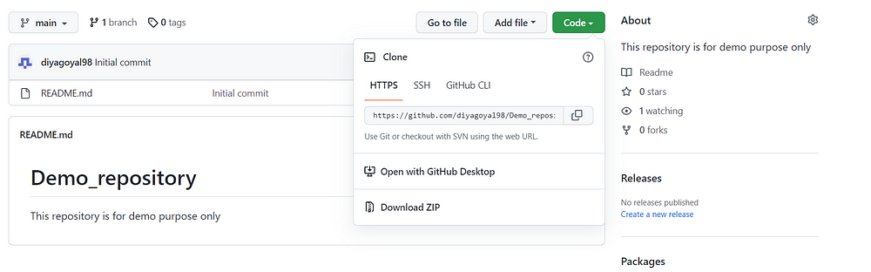

Now we are having the link to go back to the GitBash terminal and type “git clone https://link” and hit enter.

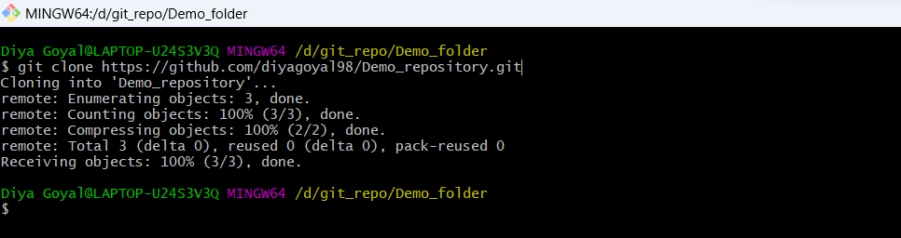

Now go to that local folder and you will find a new folder that is the same as our repo name.

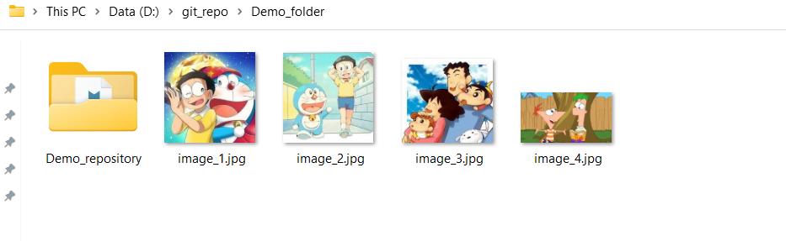

Now Just copy these files and paste them inside this demo_repository folder.

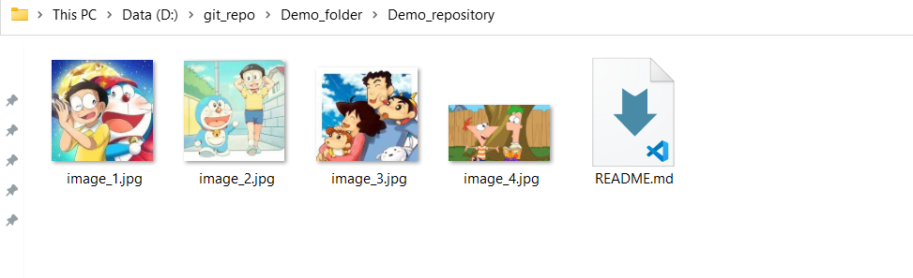

Just go to your GitBash terminal and write “ls” and hit enter this command will show all the files that are present inside that folder.

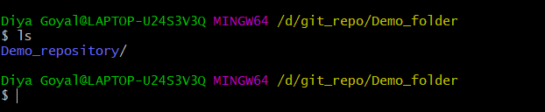

Now we have to go inside this Demo_repository folder so this we can write “cd folder name”.

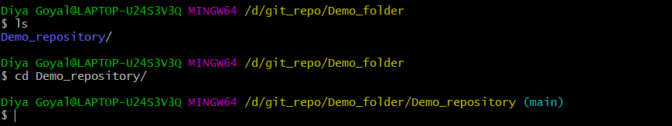

Now again we can write the 'ls' command to see what is inside the folder.

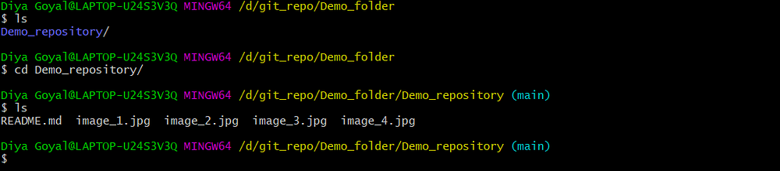

There is a command “git status” this shows the status. Whatever the changes we made in this folder and after that we execute this command then this will show us all the changes in red color.

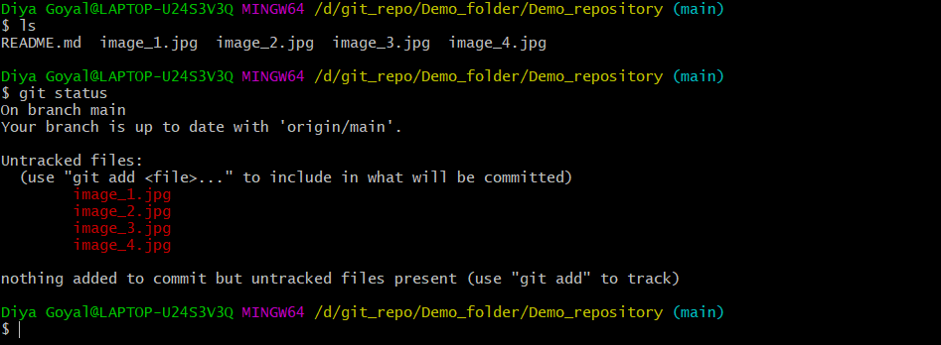

So to add these changes we will write the command “git add -A” by this whatever the changes we have made at once added to the stitched area means now if we run the git status command all files are shown in green color.

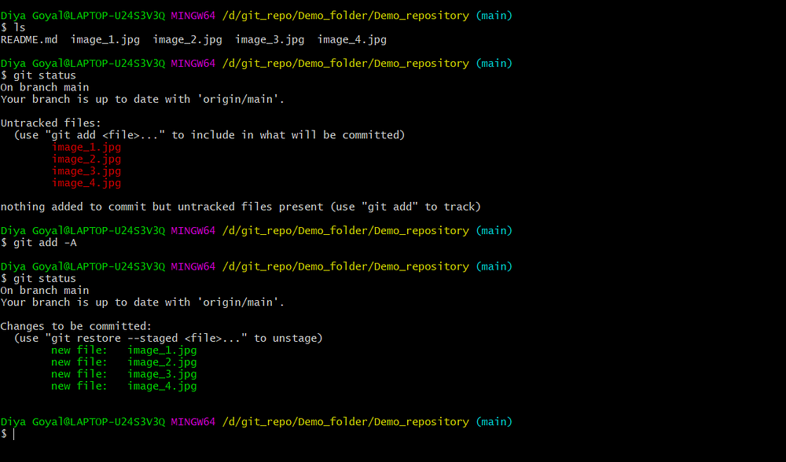

Now it is time to commit these changes we can do this by the command “git commit -m “a valid message ””.

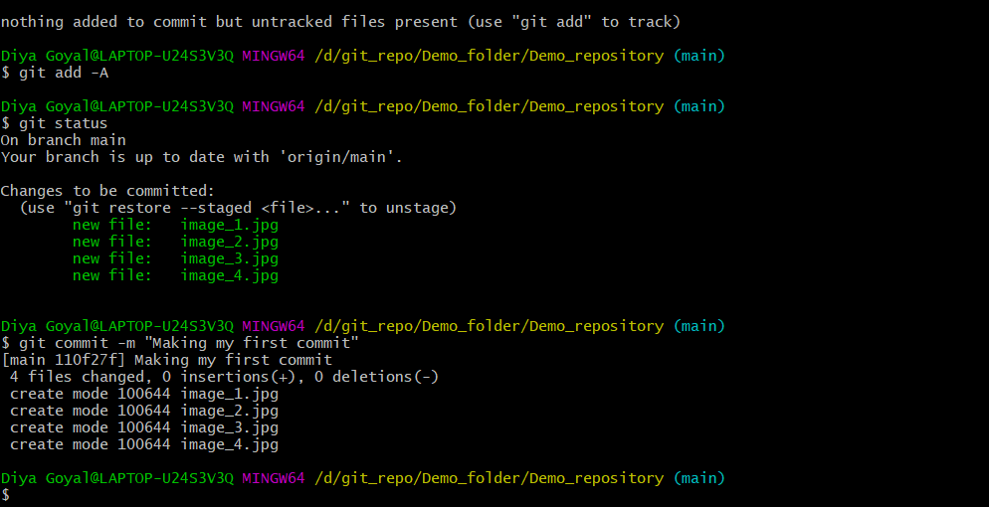

If we run the git status command it will show something like.

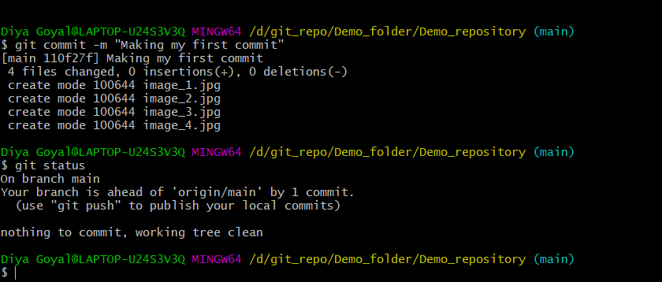

This is the last step now write the command “git push origin main” and hit enter.

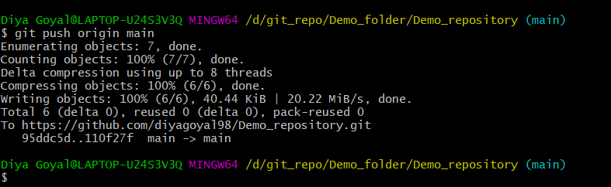

Now go to your repository and there you will find all the files that you have pushed.

